**Physically Based Rendering**

[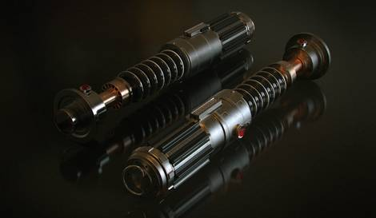](https://3dcoat.com/fileadmin/_processed_/csm_nicolas-pierquin-lightsaber_6e402f5915.jpg)

**What is Physically Based Rendering?**

[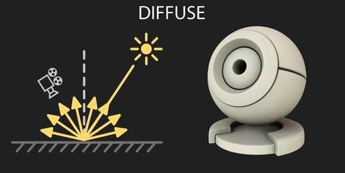](https://3dcoat.com/fileadmin/images/features/pap_diffuse.jpg)

[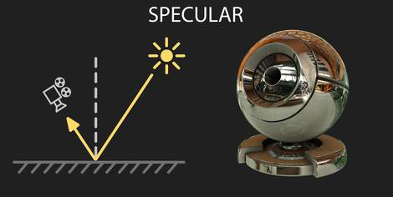](https://3dcoat.com/fileadmin/images/features/pap_specular.jpg)

    This is a rendering with some physical properties of objects being taken into account. Such an approach provides the appearance of materials as in the real world.

**How do we see things around us?**

    We can see things that surround us because rays of light go into our eye bouncing off from the surface of objects. One part of rays scatters causing a so-called diffusion effect (Diffuse), the other part is bouncing off from the surface at the opposite angle relative to the surface' normal causing a Reflection or so-called Specular.

    Metals and non-metals (Insulators) reflect and scatter light differently. Albedo, energy conservation, fresnel effect, and complex structure of relief also gives its influence into visual appearance of the surface.

**What is the difference between metals and insulators?**

[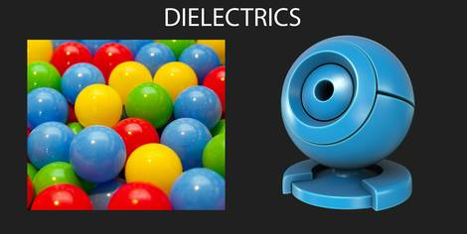](https://3dcoat.com/fileadmin/images/features/pap_dielectrics.jpg)

[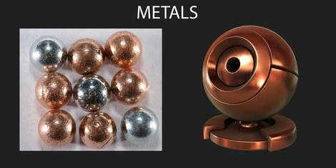](https://3dcoat.com/fileadmin/images/features/pap_metals.jpg)

[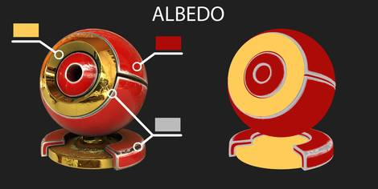](https://3dcoat.com/fileadmin/images/features/pap_albedo.jpg)

[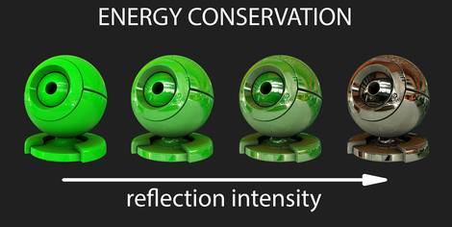](https://3dcoat.com/fileadmin/images/features/pap_energy_conservation.jpg)

[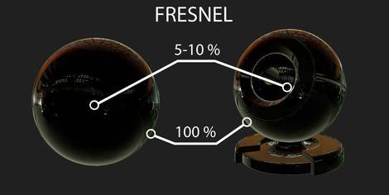](https://3dcoat.com/fileadmin/images/features/pap_fresnel.jpg)

**Insulators** are materials that have a pronounced diffuse scattering and weakly expressed specular (plastic, fabric, wood, concrete, paint and so on). Due to the diffuse scattering, we can see that the red plastic is red. And due to the reflection we can see glares on the surface.

**Metals** (steel, iron, gold, copper, brass, silver, etc.) are materials without diffuse scattering (diffusion is always black), but clearly marked with a colored reflection. Copper has a black diffusion and strong reflection of red color. Gold has a black diffusion and a bright yellow reflection. Silver has a black diffusion and bright white reflection.

**What is Albedo?**

    This is the amount of energy of the reflected and scattered light. Roughly speaking, the color of the surface of the material that we see whether it is insulator or metal. Insulator's albedo and diffusion color matches, while the metal's don't. All metals have black diffusion, but we do not see them black, due to the reflection. For example, we see gold to appear yellow rather than black as its diffusion. For this reason the albedo is more convenient to use for the artist.

**What is Energy Conservation?**

     Simply put, the higher the intensity of the reflection, the lower the intensity of the diffuse scattering. That's because the sum of both diffuse and reflection scattering intensity can not exceed the intensity of the ray of light that fell on the surface.

**What is Fresnel effect?**

     The easiest way to describe it - the smaller the angle of incidence of light on the surface, the stronger the reflection will be. All materials in the nature have this effect. Interestingly, at 0 degrees all materials reflect 100 percent of light, but reflection appearance suffers because of the complex surface structure.

**How does material surface's structure influence the reflection?**

[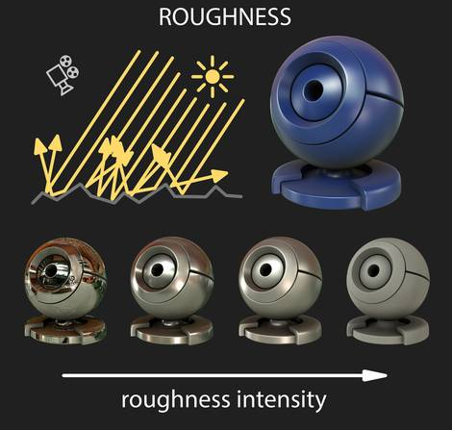](https://3dcoat.com/fileadmin/images/features/pap_roughness.jpg)

    This can be virtually any surface comprised with micro-relief, tiny pores, depressions or scratches that are only visible under a microscope. This causes the effect of surface roughness, when the reflection looks blurred. If the surface is perfectly smooth, without micro-relief, then the reflection will be perfectly clear.

**So what should the Artist do with all that Physics?**

     Texturing is now much easier! The principle of energy conservation and the Fresnel effect works without any interference, the Artist needs only 3 textures:

**Albedo** ― a colored texture of surface's color.

**Metalness** ― a black and white texture, where black pixels defines an insulator surface, and white defines metal.

**[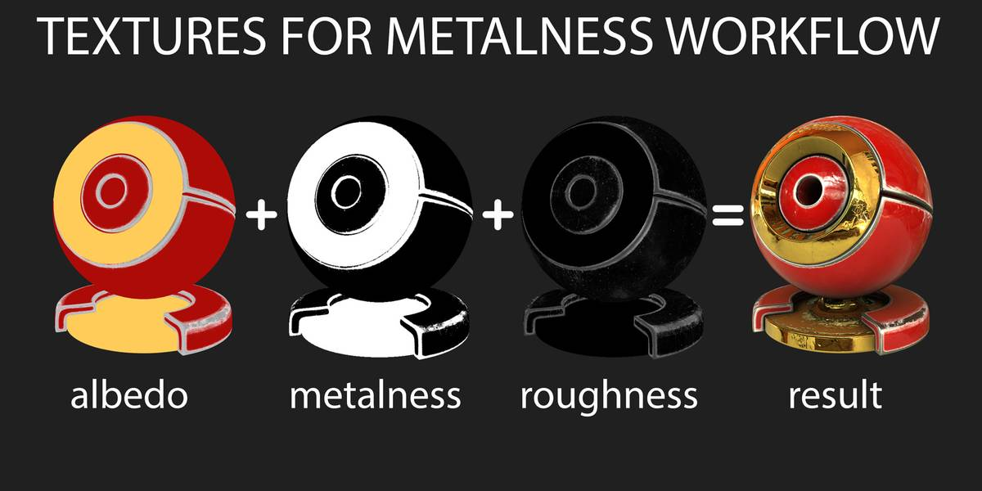](https://3dcoat.com/fileadmin/images/features/pap_textures_metalness.jpg)Roughness** ― a black and white texture, the lighter the pixel the more blurred reflection will be.